**Réseaux/Networks**

**TP2**

Lab-View Network Device MAC Addresses ………………………………………… 2

Lab - View the Switch MAC Address Table ………………………………………… 8

Packet Tracer-Build a Switch and Router Network - Physical Mode …… 17

Packet Tracer - Examine the ARP Table ……………………………………………… 26

G2:

GUO Xiaofan

LIN Yingqi

YIN Chenghao

# Lab-View Network Device MAC Addresses

**Part1**

Step 1

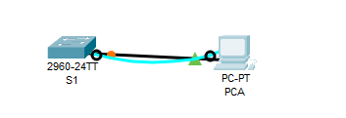

Step 2:

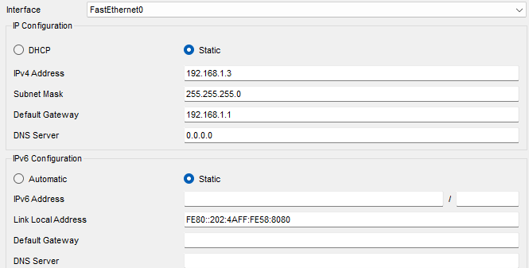

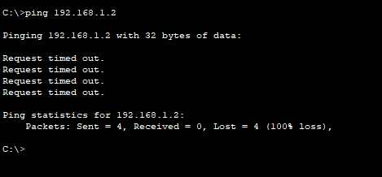

The pings were not successful yet, because the switch has not been configured.

Step 3:

a.&b.&c.&d.

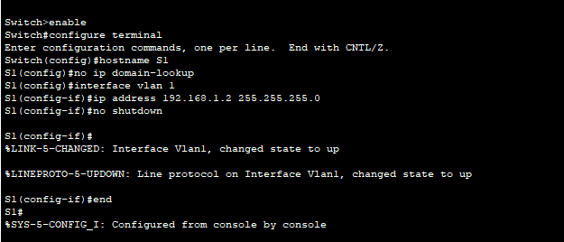

Step 4:

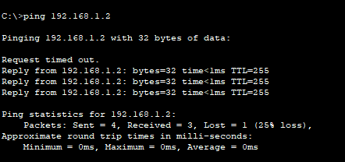

The pings were successful.

**Part 2**

Step 1:

（a）

* **What is the OUI portion of the MAC address for this device?**

5C-26-0A*Type your answers here.*

* **What is the serial number portion of the MAC address for this device?**

24-2A-60*ype your answers here.*

* **Using the example above, find the name of the vendor that manufactured this NIC.**

Dell Inc.

(b)

From the command prompt on PC-A, issue the ipconfig /all command and identify the OUI portion of the MAC address for the NIC of PC-A.

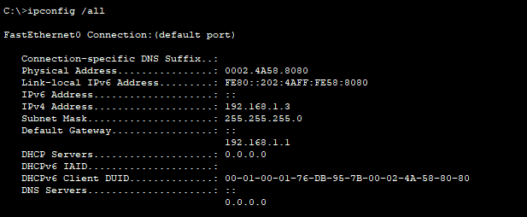

* **identify the OUI portion of the MAC address for the NIC of PC-A.**

00-02-4A

* **Identify the serial number portion of the MAC address for the NIC of PC-A.**

58-80-80

* **Identify the name of the vendor that manufactured the NIC of PC-A.**

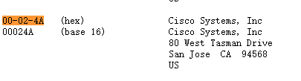

Cisco Systems, Inc

Step 2:

Console into S1 and use the show interfaces vlan 1 command to find the MAC address information.

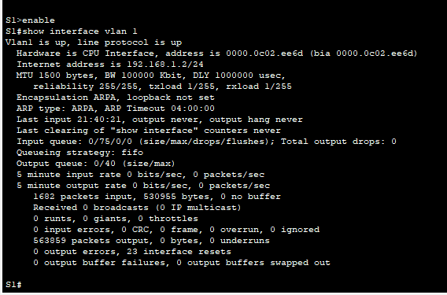

* **What is the MAC address for VLAN 1 on S1?**

0000.0c02.ee6d

* **What is the MAC serial number for VLAN 1?**

02-ee-6d***s here.***

* **What is the OUI for VLAN 1?**

00-00-0C*Type your answers here.*

* ***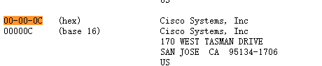*Based on this OUI, what is the name of the vendor?**

Cisco Systems.

* **What does bia stand for?**

Burned in address.

* **Why does the output show the same MAC address twice?**

The MAC address can be changed via a software command and the actual address will still be there.

(b)

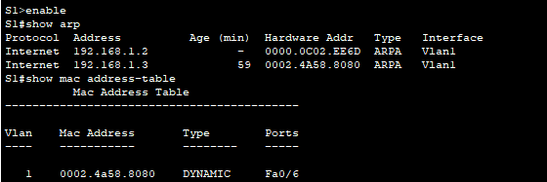

* **What Layer 2 addresses are displayed on S1?**

0000.0C02.EE6D

0002.4A58.8080***.***

* **What Layer 3 addresses are displayed on S1?**

192.168.1.2

192.168.1.3

Step 3:

* **Did the switch display the MAC address of PC-A? If you answered yes, what port was it on?**



Yes. Port should be F0/6, the MAC address would be 0002.4a58.8080.

**Reflection Questions**

**1. Can you have broadcasts at the Layer 2 level? If so, what would the MAC address be?**

I can have broadcasts at Layer 2.

ARP will use broadcasts to find MAC address information.

The broadcast address is FF.FF.FF.FF.FF.FF.

**2. Why would you need to know the MAC address of a device?**

In a large network, it may be easier to pinpoint location and identity of a device by its MAC address instead of its IP address. The MAC OUI will list the manufacturer, which may help narrow down the search. Security measures can be applied at Layer 2, so knowledge of allowable MAC addresses is needed.

# Lab - View the Switch MAC Address Table

**Part 1**

Step 1:

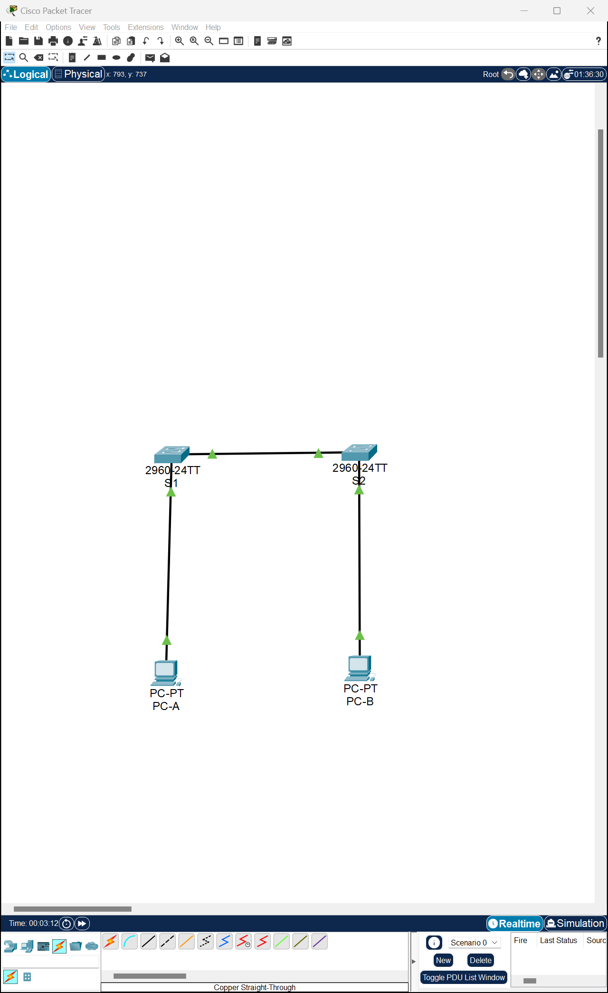

Step 2:

Step 3:

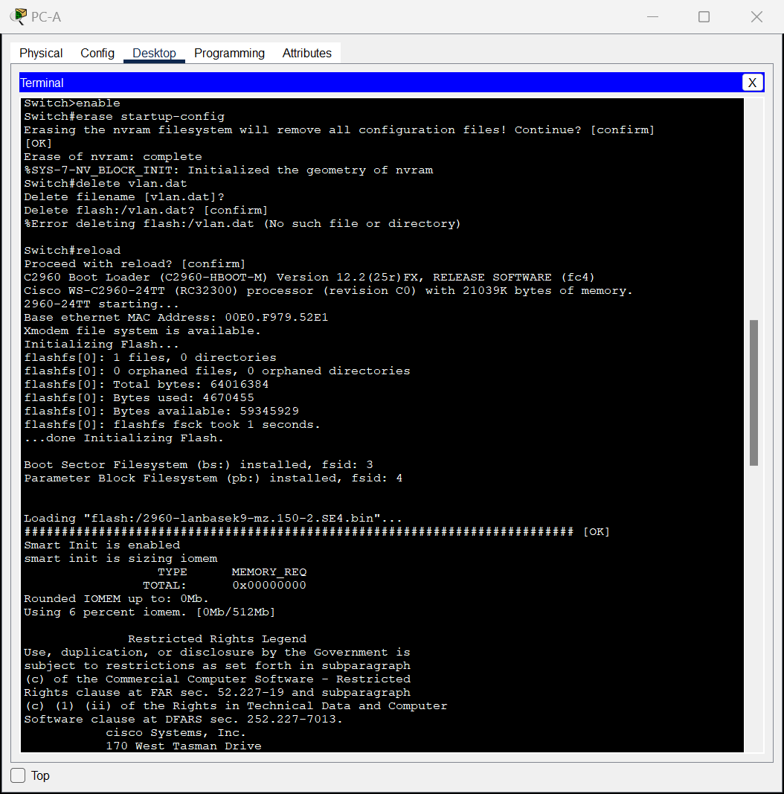

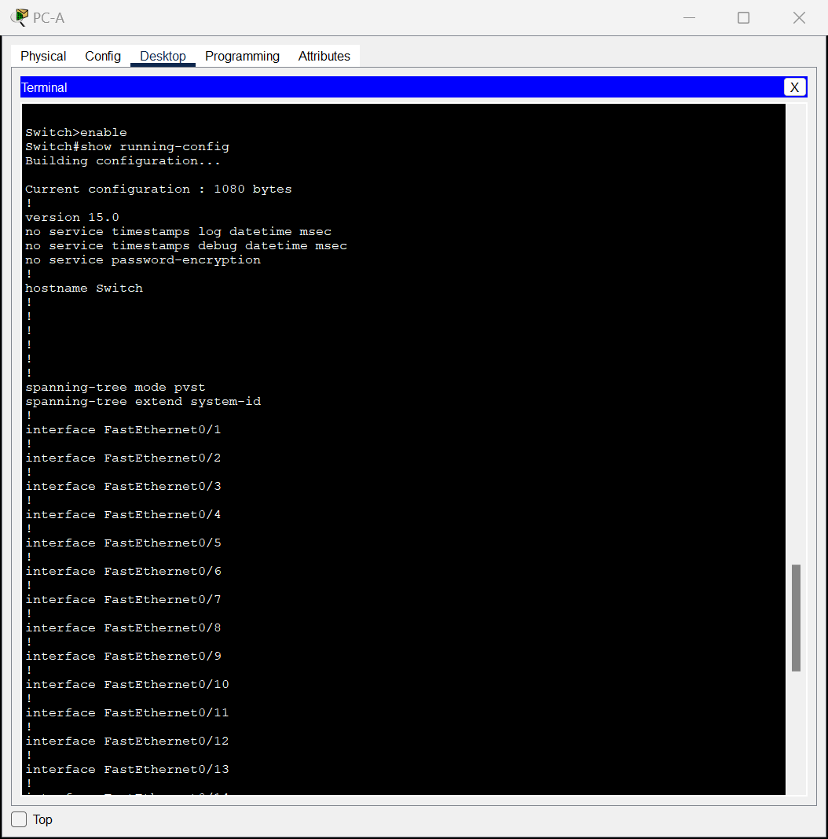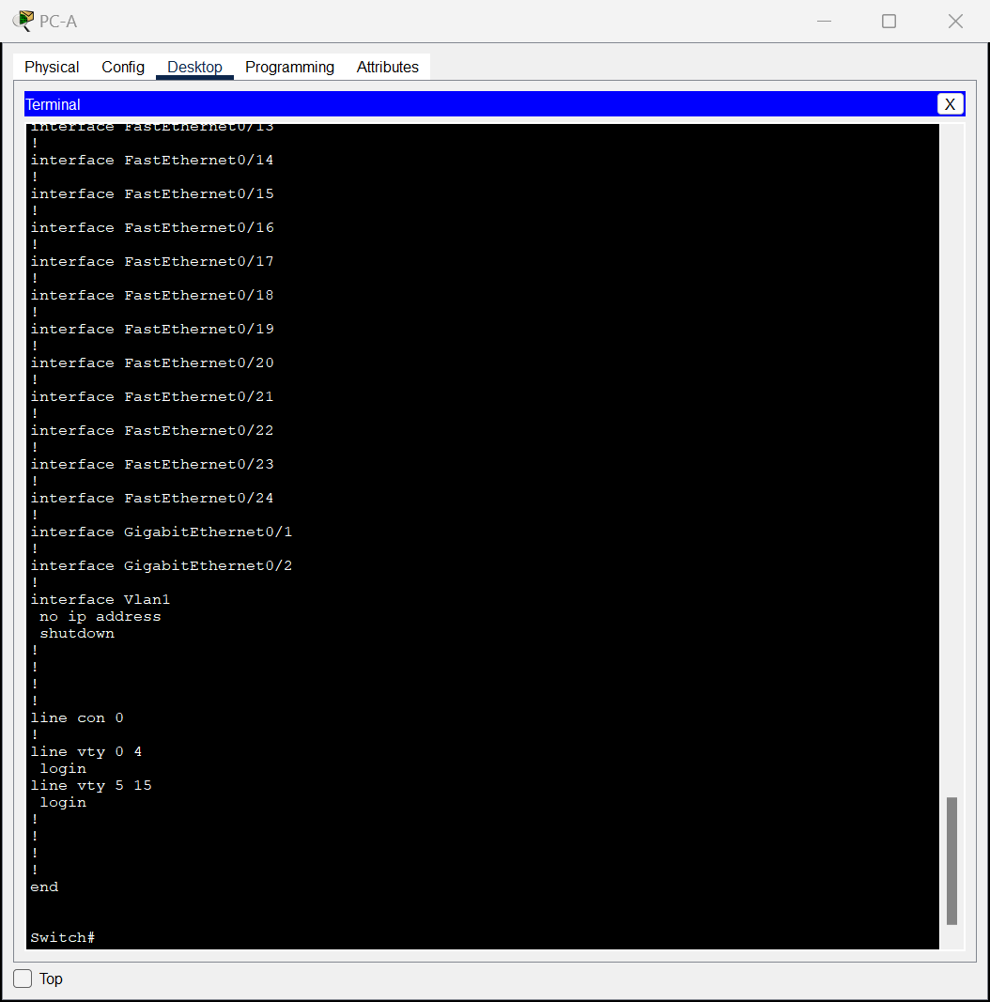

Step 4:

**图形用户界面

**a.

b.

c.

d.



**Part2**

Step 1:

**PC-A MAC Address:** 00E0.F9D2.1845

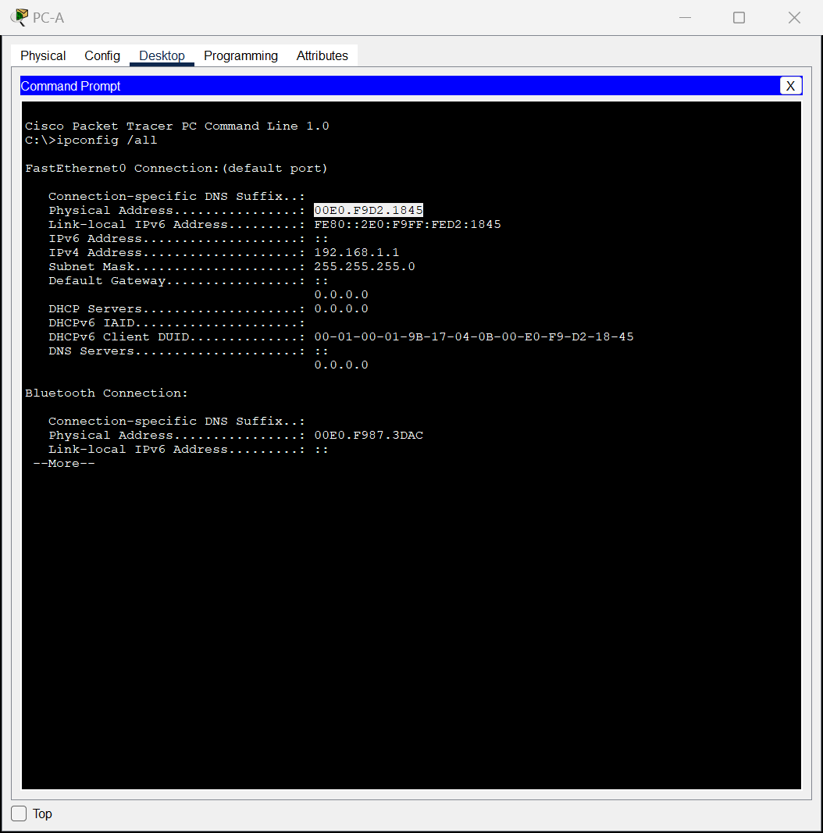

**PC-B MAC Address:** 00D0.FF9D.444D

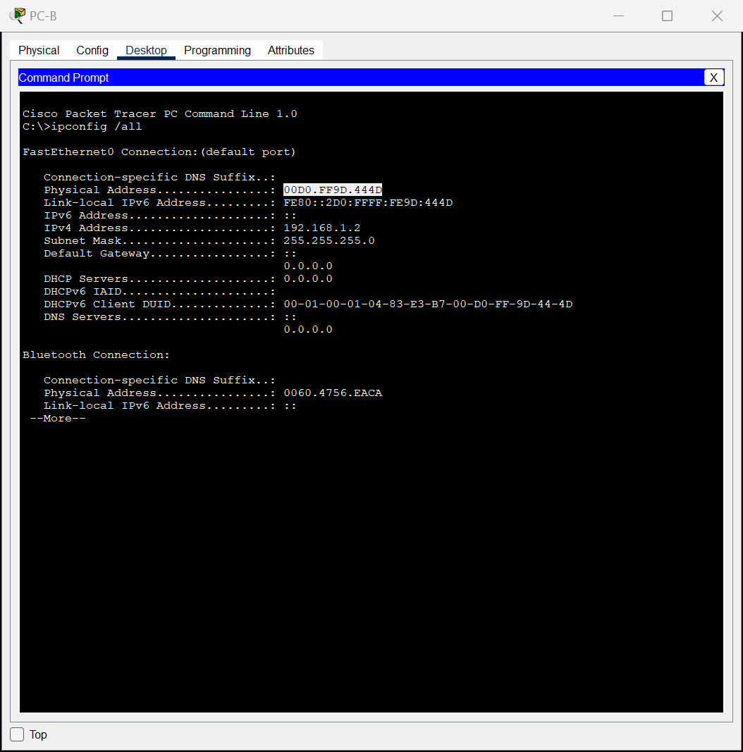

**S1 Fast Ethernet 0/1 MAC Address**: 0002.1732.3301

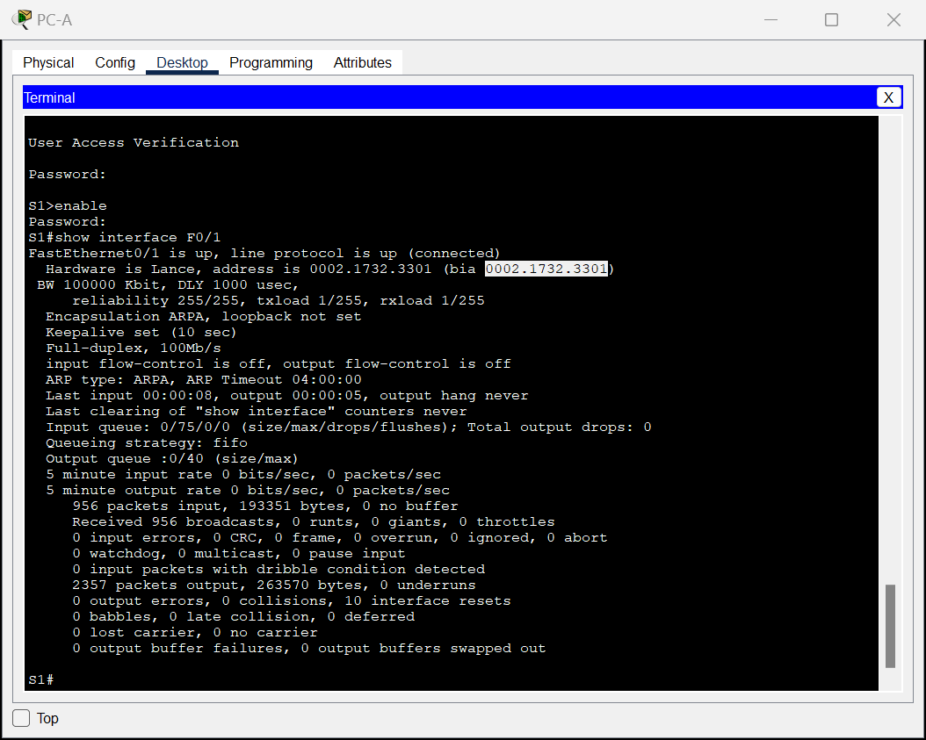

**S2 Fast Ethernet 0/1 MAC Address**: 0001.9651.1e01

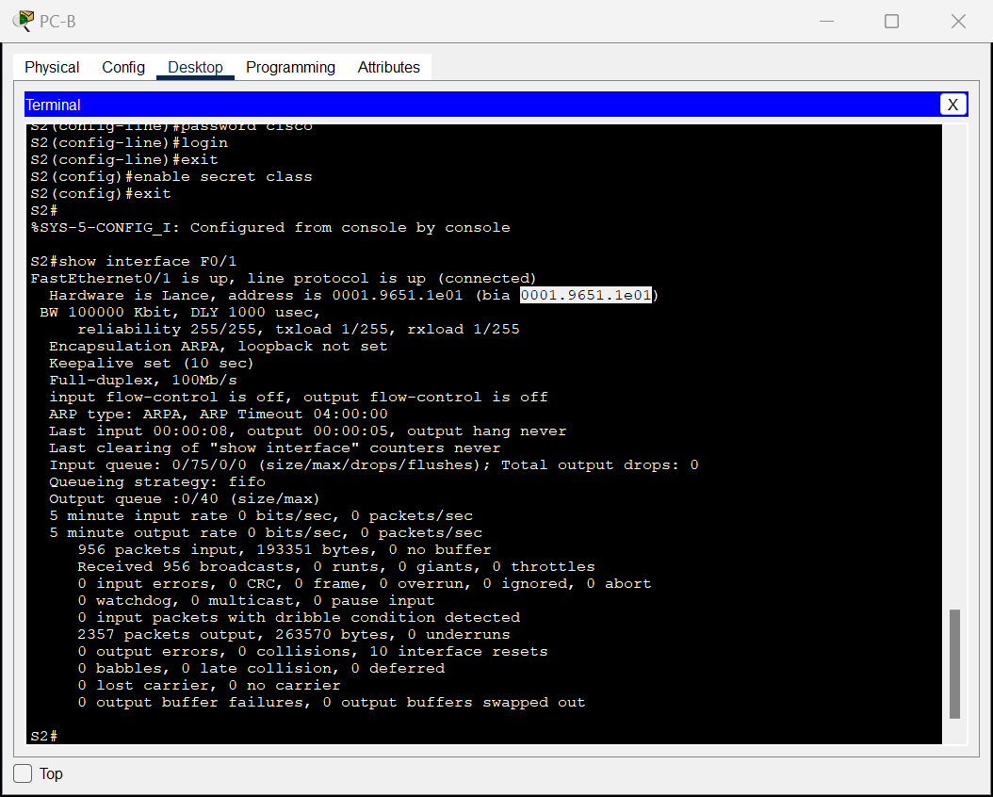

Step 2:

a.

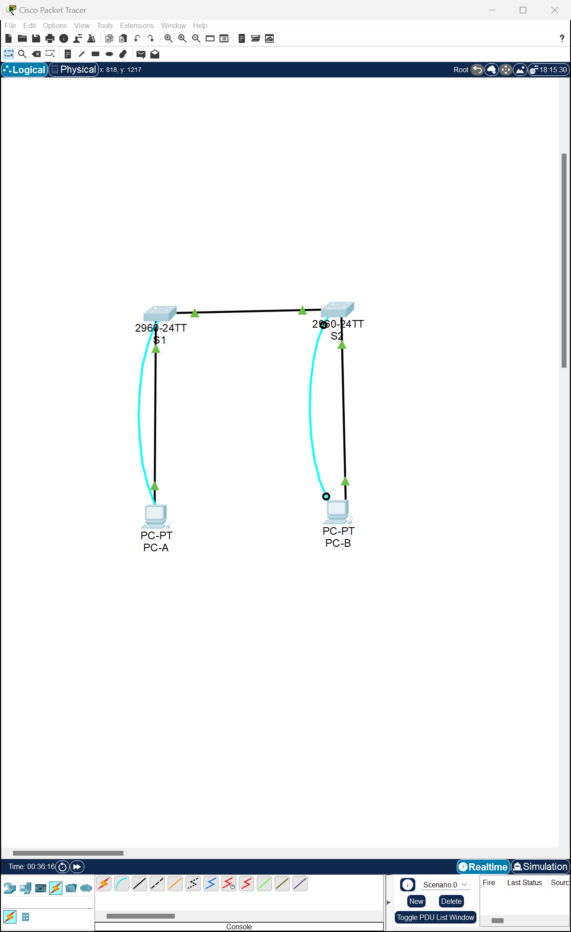

b.

* **Are there any MAC addresses recorded in the MAC address table?**

Yes.

* **What MAC addresses are recorded in the table? To which switch ports are they mapped and to which devices do they belong? Ignore MAC addresses that are mapped to the CPU.**

The S1’s MAC address recorded in via Fa0/1 switch port.

* **If you had not previously recorded MAC addresses of network devices in Step 1, how could you tell which devices the MAC addresses belong to, using only the output from the show mac address-table command? Does it work in all scenarios?”** show mac address-table command” shows the port that the MAC addresses were learned on and it would identify the MAC address belongs to which network device in the simple network system.

But when multiple MAC addresses associated to the same port or the device uses a dynamic address, MAC addresses might not be directly correlated with specific devices.

Step 3:

a.

b.

* **Does the MAC address table have any addresses in it for VLAN 1? Are there other MAC addresses listed?**

No. Just S1’s MAC address re-recorded in via Fa0/1 switch port.

* **Wait 10 seconds, type the show mac address-table command, and press Enter. Are there new addresses in the MAC address table?**No, the same line showed.

Step 4:

a.

* **Not including multicast or broadcast addresses, how many devices IP-to-MAC address pairs have been learned by ARP?**

ARP cache have no entries in it.

b.

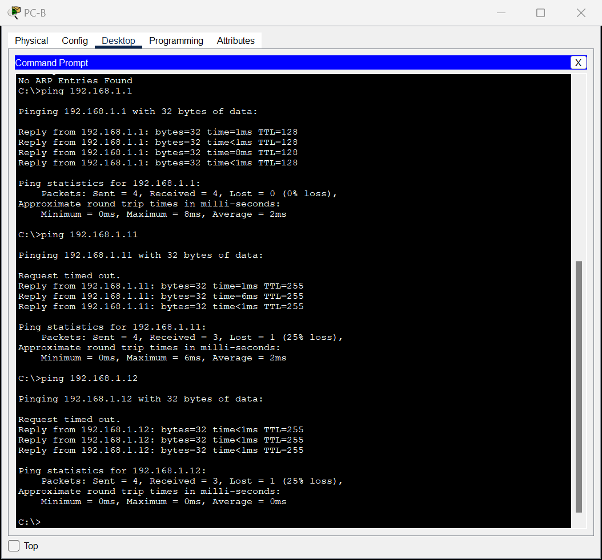

* **Did all devices have successful replies? If not, check your cabling and IP configurations.**

Yes, all devices have successful replies.

c.

* **Has the switch added additional MAC addresses to the MAC address table? If so, which addresses and devices?**

Yes, including S1(1st line), PC-A(4th line) , PC-B(2nd line),

文本

* **Does the PC-B ARP cache have additional entries for all network devices that were sent pings?**

Yes, PC-A(1st line), S1(2nd line), S2(3rd line).

**Reflection Question:** what might be some of the challenges on larger networks?

1. **ARP Cache Size Limitations:** on the large network system, the number of entries may surpass the capacity of the caches.
2. **MAC Address Table Scalability:** the number of MAC addresses can handle may limited.
3. **Dynamic Nature of Devices:** Devices on the large network are often dynamic, the displayed data deviates from the real situation.

# Packet Tracer-

# Build a Switch and Router Network - Physical Mode

**Part1**

**Part2**

Step1

a.

b.

c.

The router interfaces, which serve as the default gateways, have not been configured. As a result, Layer 3 traffic is not being forwarded between the subnets.

Step2

a.

b.

b.

cd.

e.

f.

g.



h.

i.

j.

k.



l.

m.

n.

The router is actively directing traffic between the two subnets. The default settings on the switch automatically activate the interfaces connected to devices.

Step3:

a.

b.&c.

d.&e.

f.

Step4:

a.

b.

**Part3:**

Step1:

图形用户界面

* **What code is used in the routing table to indicate a directly connected network?**

Both "C" and "L" designations are valid. "C" signifies a directly connected subnet, while "L" designates a local interface. Both responses are accurate.

* **How many route entries are coded with a C code in the routing table?**

2.

* **What interface types are associated to the C coded routes?**

G0/0/0 and G0/0/1.

b.

Step2:

a.

* **What is the operational status of the G0/0/1 interface?**

G0/0/1 is up, line protocol is up.

* **What is the Media Access Control (MAC) address of the G0/1 interface?**

0060.4731.8102

* **How is the internet address displayed in this command?**

Internet address is 192.168.1.1/24.

b.

Step3:

a.

b.

c.

**Reflection Questions**

**1. If the G0/0/1 interface showed that it was administratively down, what interface configuration command would you use to bring the interface up?**

R1(config-if)# no shutdown

**2. What would happen if you had incorrectly configured interface G0/0/1 on the router with an IP address of 192.168.1.2?**

PC-A cannot successfully ping PC-B due to being on separate networks. For proper communication, PC-A relies on the default-gateway router to route packets to PC-B. However, PC-A is configured with the default-gateway address of 192.168.1.1, which is not assigned to any device on the LAN. Consequently, packets requiring routing through the default-gateway cannot reach their intended destination.

# Packet Tracer - Examine the ARP Table